**Order Creation by Manifest**

1. Go to “New Order” from left hand side “Activities” menu

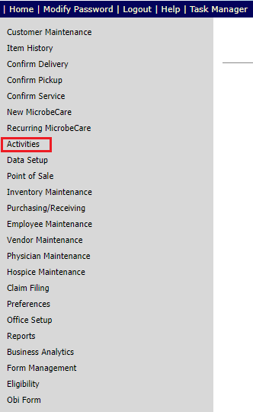

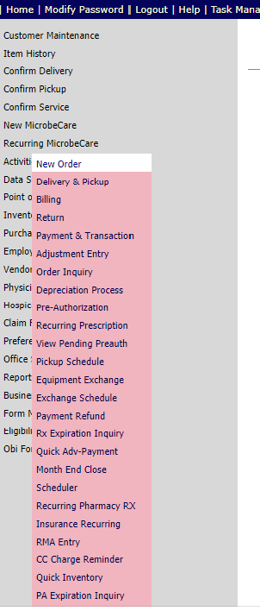

1. Search a customer by customer id/Customer Name/ Customer First Name/Social Security No./Phone No.

Example: **Customer Id-12161**

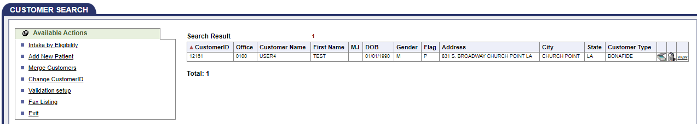

1. Click on the customer
2. Select “Sales Rep.” under “Customer Information” tab

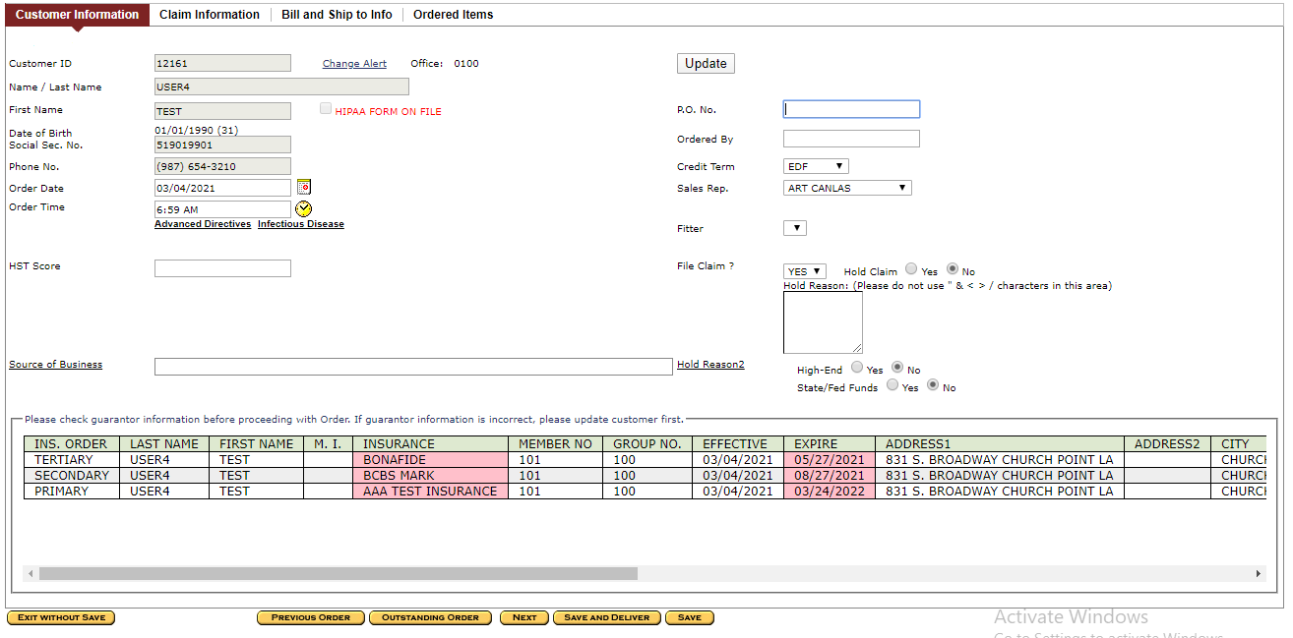

1. Go to “Ordered Items” tab
2. Search an item by any search criteria

Ex: SKU- _T_TEA

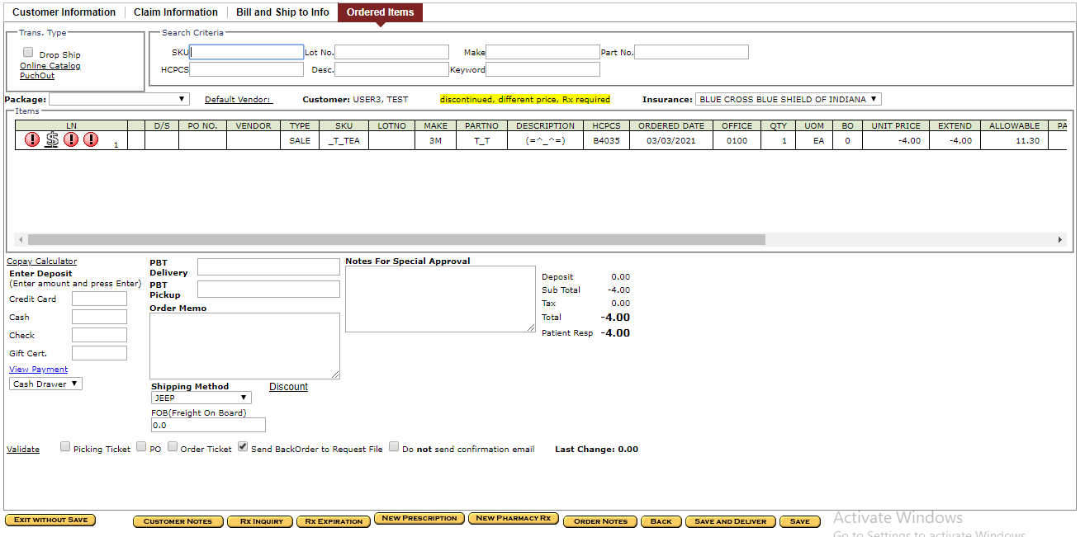

1. Click “Save AND Delivery” button
2. Note down “Order no” and accept alert if any occoured(Ex: 7898)

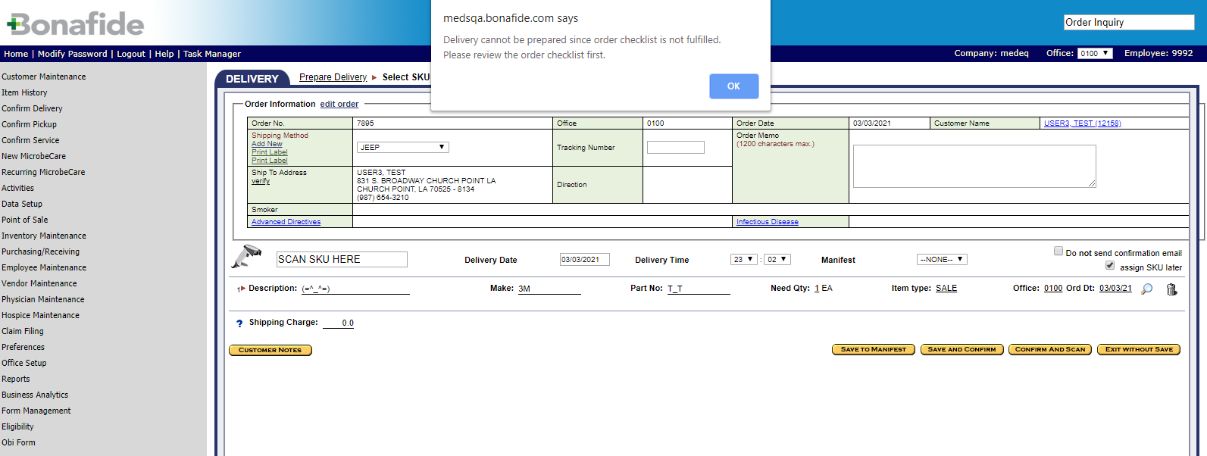

1. Go to “Order Inquiry” from left hand side “Activities” menu

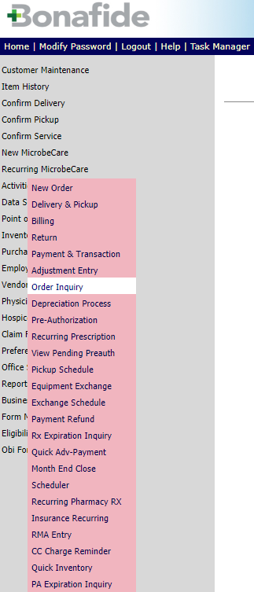

1. Click on the Order No.

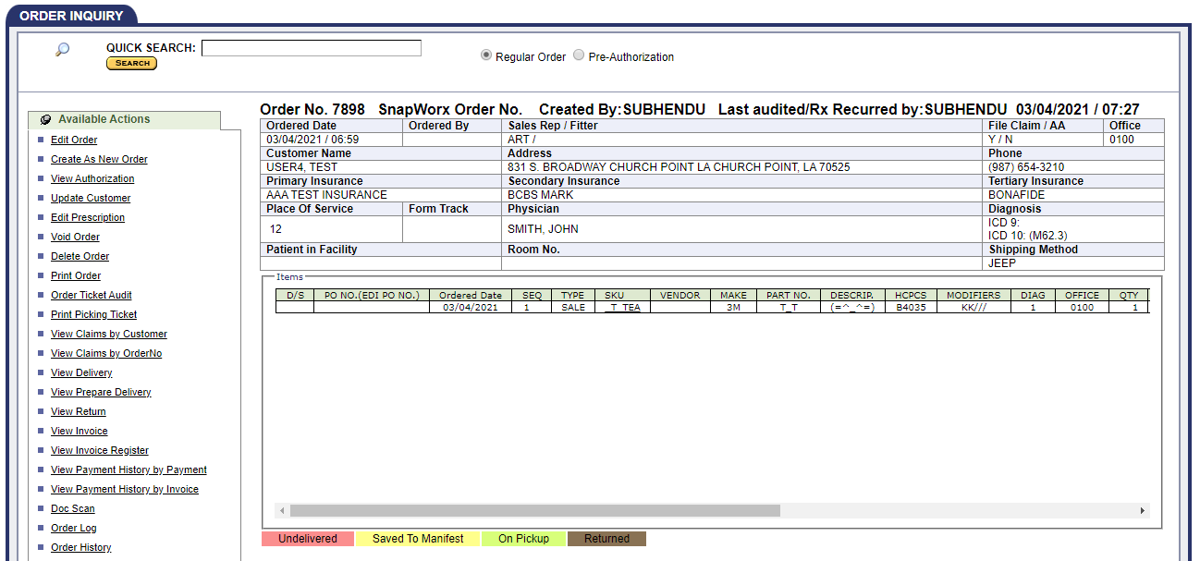

1. Click on “Order Checklist” link on the left hand side under “Available Action”

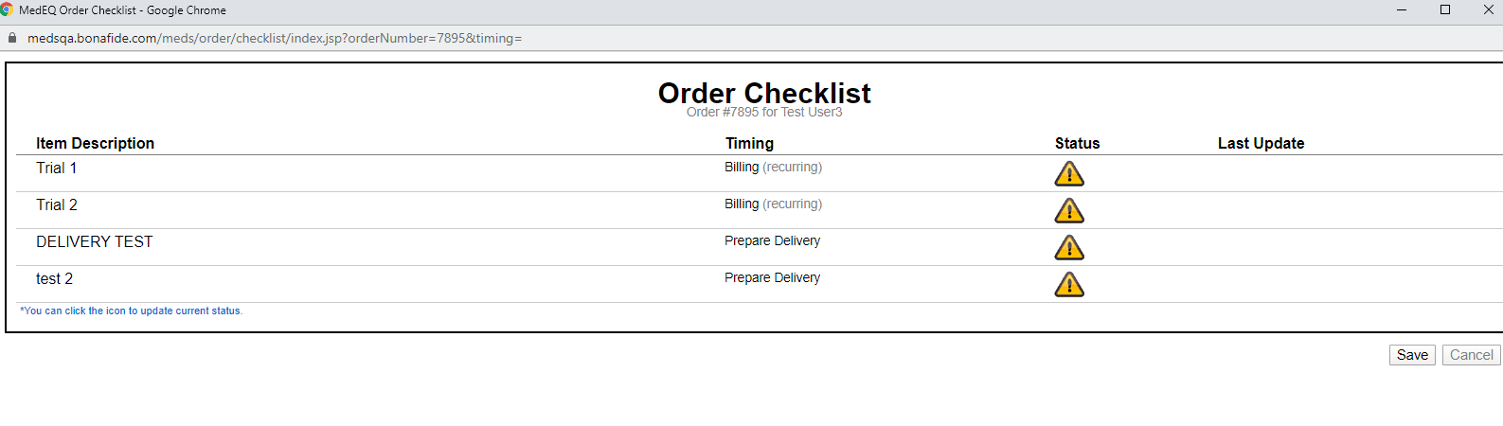

1. Check all the status and click on “Save” button



1. Click on “Edit Order” link on the left hand side under “Available Actions”

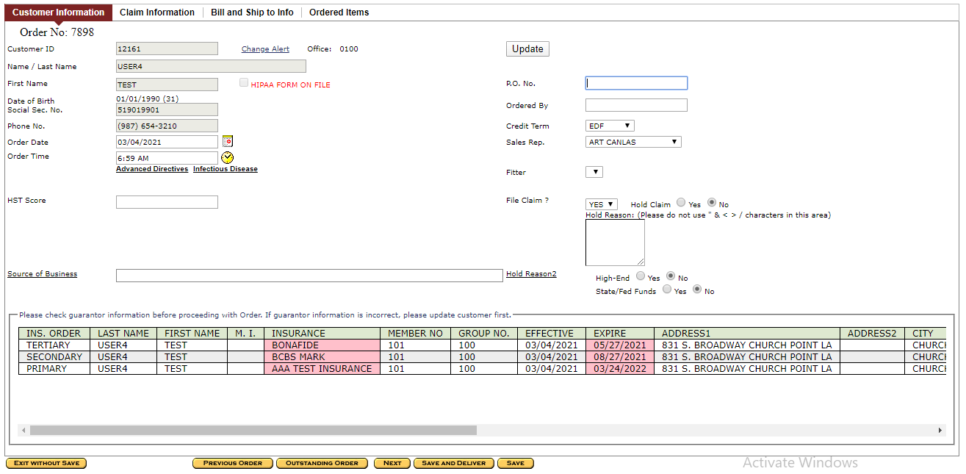

1. Click on “Save AND Deliver” button

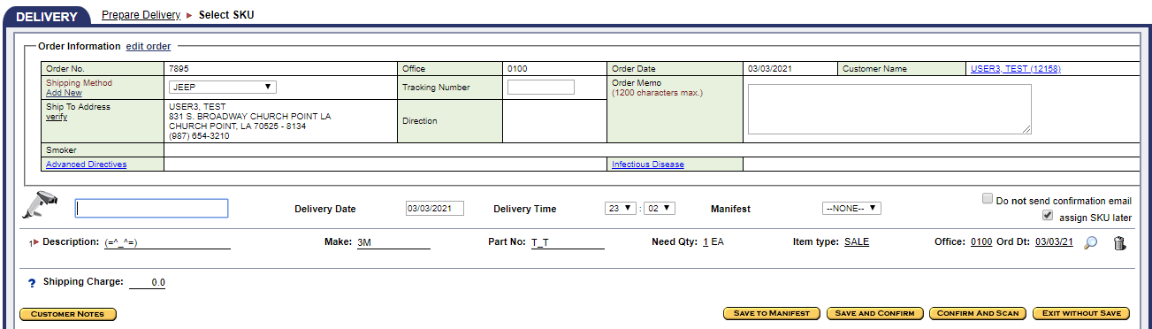

1. Assign SKU No by clicking on the magnifing glass icon

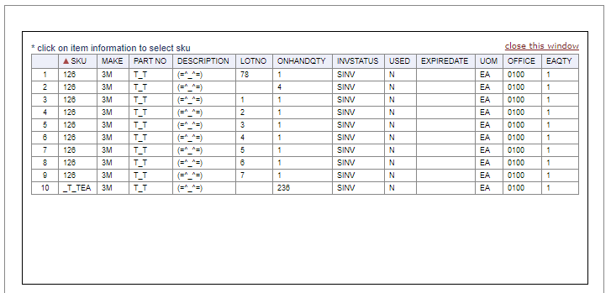

1. Select “Manifest” from drop down and Click on “Save To Manifest”

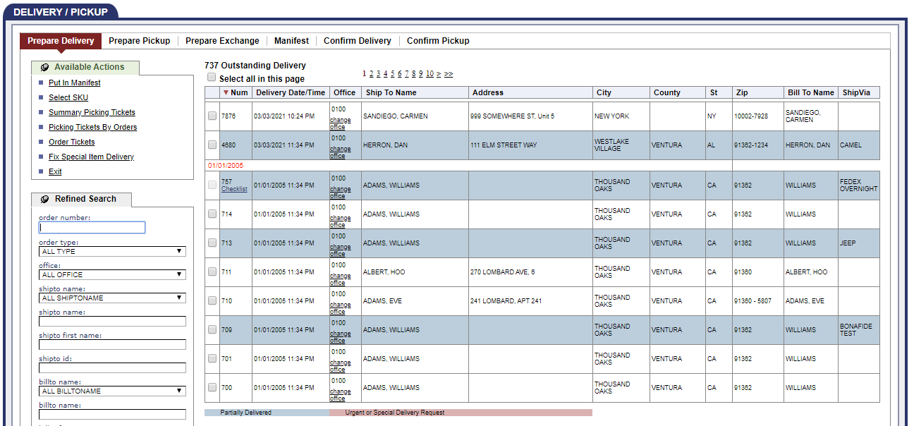

1. Go to” Confirm Delivery” tab
2. Search the Order no(7898)

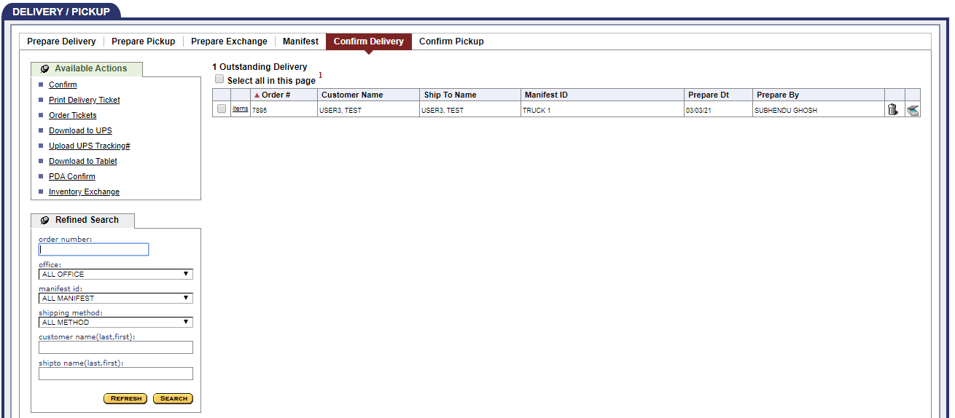

1. Check the checkbox and click on “Confirm” link on the left hand side under “Available Action”
2. Get a “Confirm Success” alert

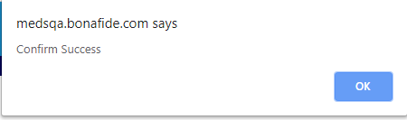

**Order creation without Manifest**

1. Go to “New Order” from left hand side “Activities” menu





1. Search a customer by customer id/Customer Name/ Customer First Name/Social Security No./Phone No.

Example: **Customer Id-12160**

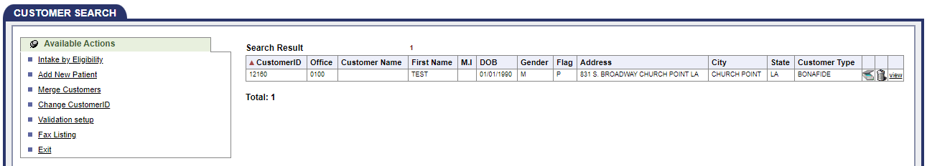

1. Click on the customer
2. Select “Sales Rep.” under “Customer Information” tab

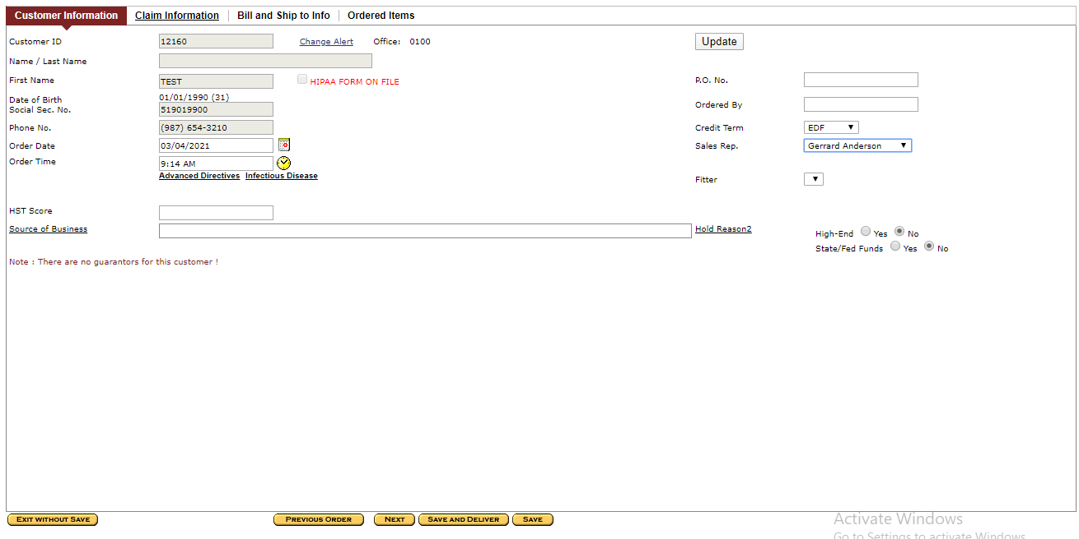

1. Go to “Ordered Items” tab
2. Search an item by any search criteria

Ex: SKU- _T_TEA

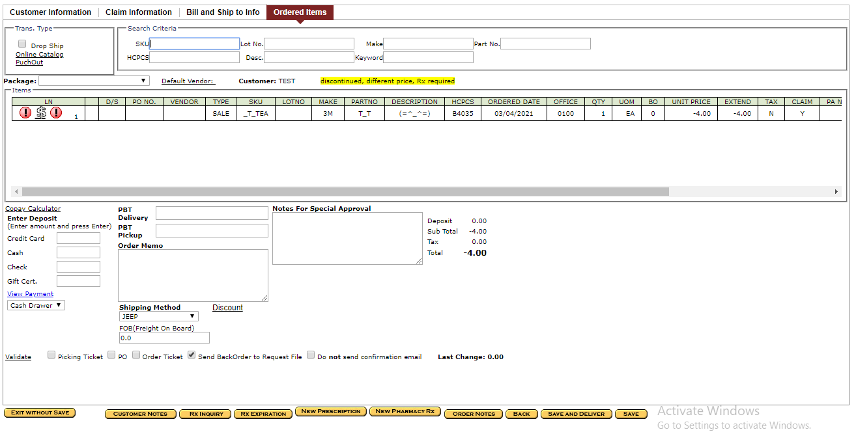

1. Click “Save AND Delivery” button
2. Note down Order no and accept alert if any occoured(Ex: 7899)

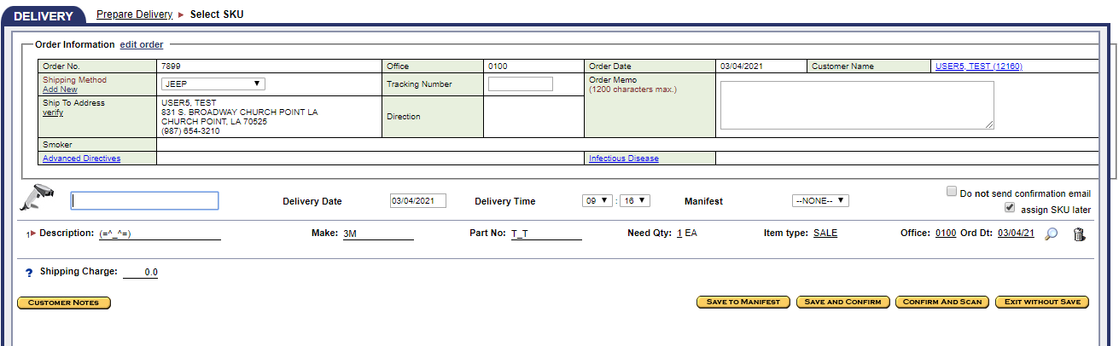

1. Go to” Order Inquiry” from left hand side “Activities” menu



1. Click on the Order No.

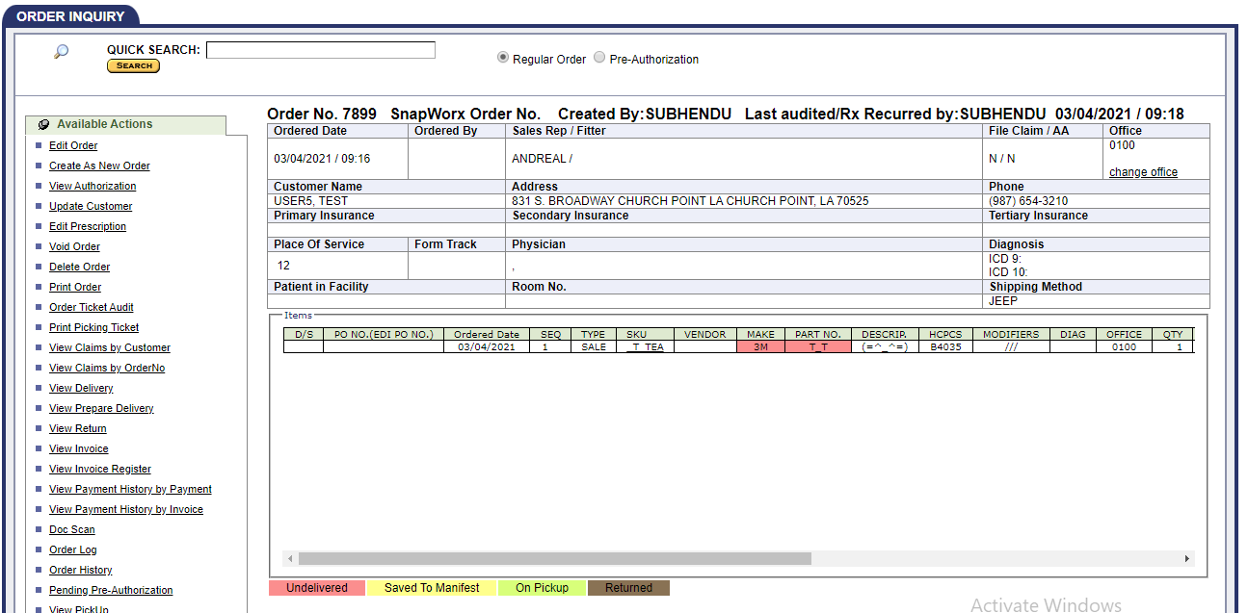

1. Click on “Order Checklist” link on the left hand side under “Available Action”



1. Check all the status and click on “Save” button



1. Click on “Edit Order” link on the left hand side under “Available Action”

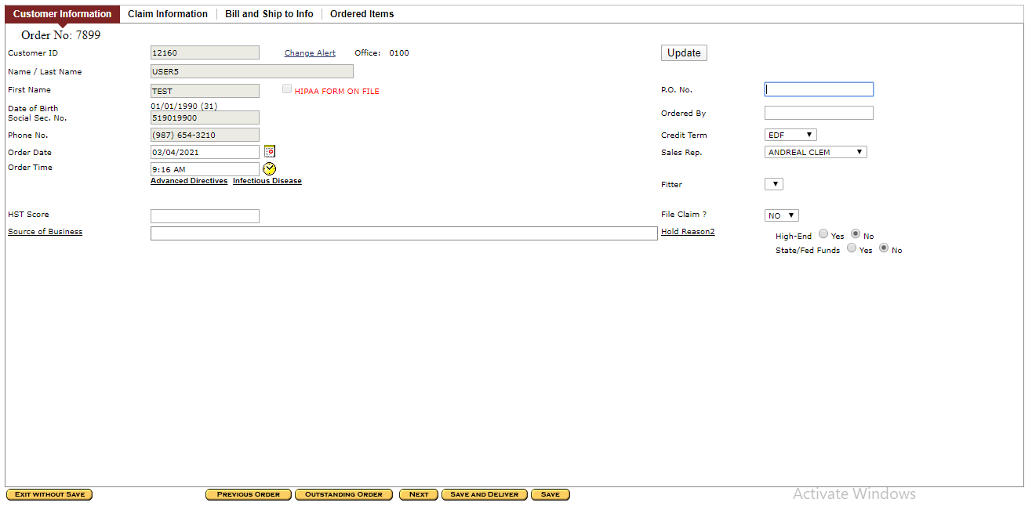

1. Click on “Save AND Deliver” button.

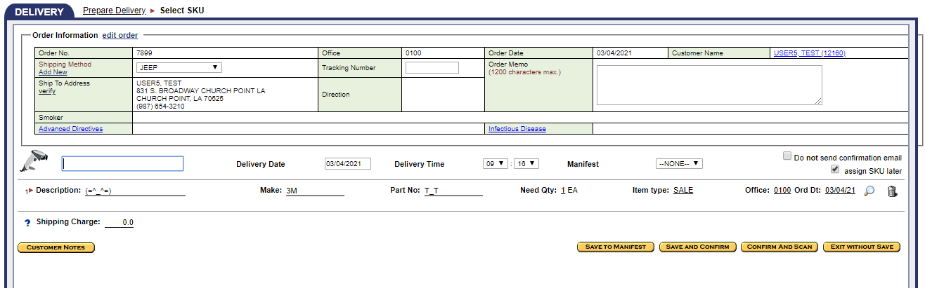

1. Assign SKU No by clicking on the magnifing glass icon

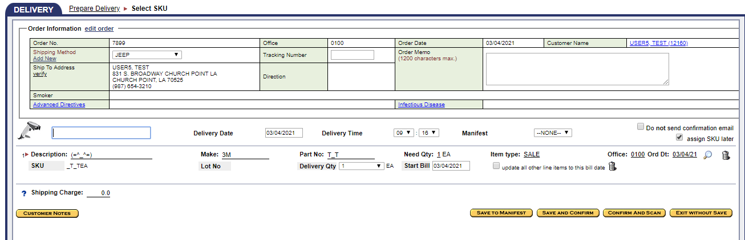

1. Click on “Save AND Confirm” button
2. Click on “Go To Delivery” button

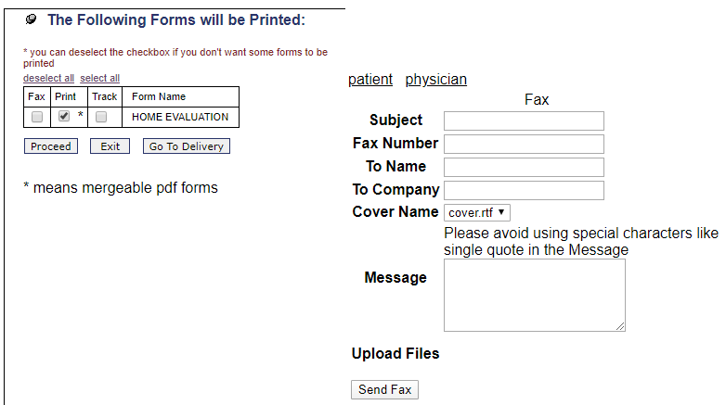

1. Go to “Order Inquiry” from left hand side “Activities” menu



1. Click on the Order No.

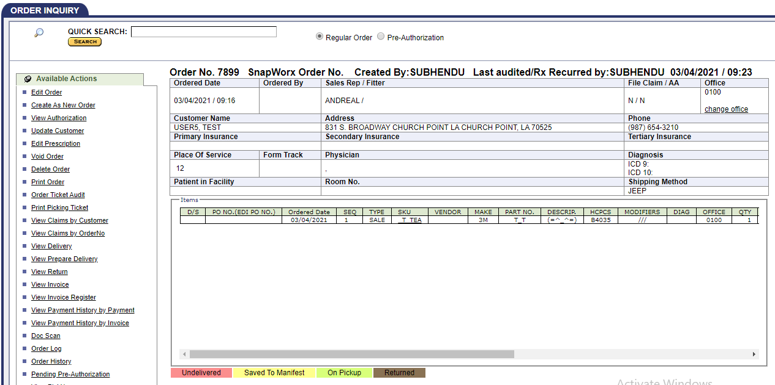

1. Click on “View Delivery” link on the left hand side under “Available Action”



1. Delivery No will be generated.

Please check the above delivery no- 7251 as reference.

**Create order with facility**

1. Edit a Order and Change File Claim to “No”

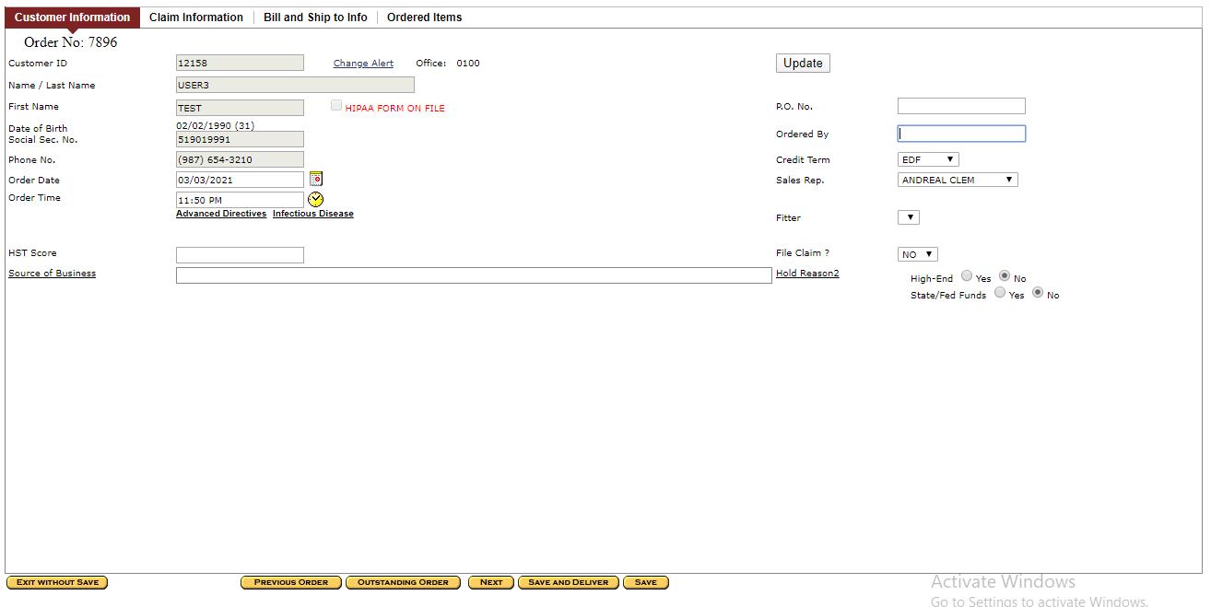

1. Go to Bill and Ship to info tab and click on Get Bill To ID

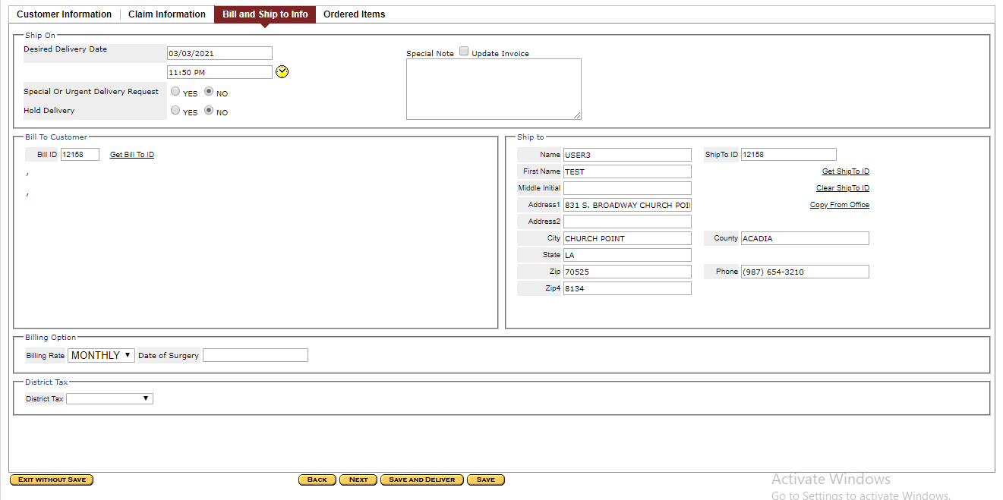

1. Enter the facility name in the customer name field and click on search

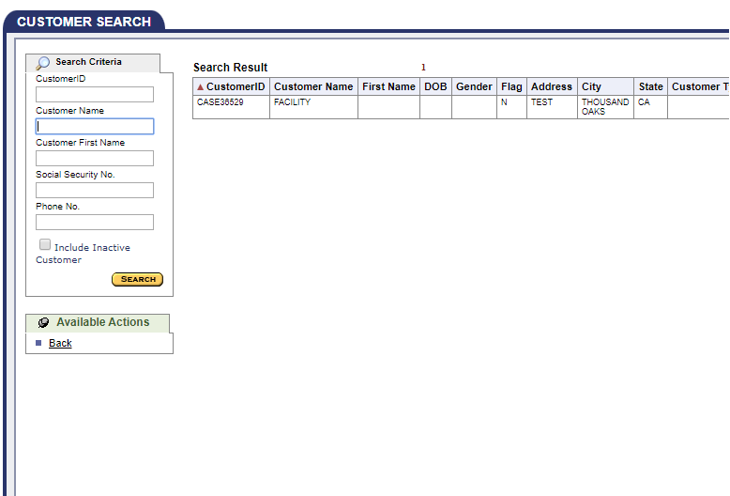

1. Click on faclity
2. Facility window will close and facility info will update at Bill to Customer Section

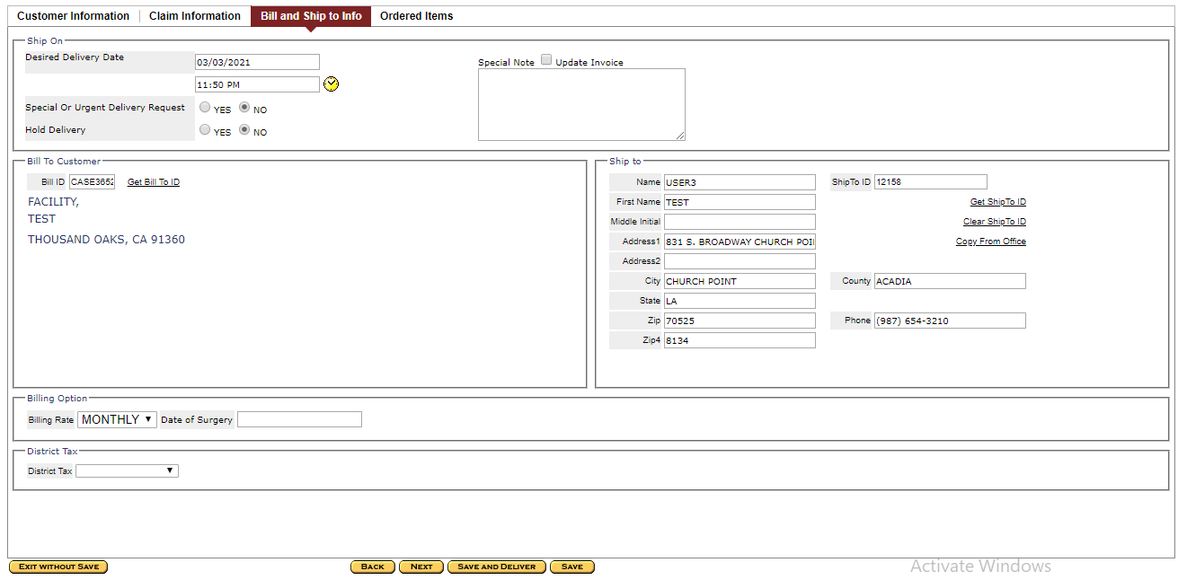

1. Click on Save and Delivery

